React JS
- React is a JavaScript library for building user interfaces.
- React is used to build single-page applications.
- React allows us to create reusable UI components.
- React is a free & open source library.

- Install Node & NPM (Node Always install Recommended for most users)
- Install Code Editor (VS Code)
After Install Node, Start Command line and create the project directory
Some Useful Command :
cd Desktop = Go to the desktop.
Node –v = check node version.
Npm –v = check npm version.
mkdir abc = create the folder abc.
cd abc = go inside the abc folder.
npx create-react-app blog = create the blog name react application.(name always in small characters).
It take some time to create project which is depend of internet speed.
code . = After create the project open it with vs code using these command.
npm start = start(run) the project on browser.

What is JSX?
- JSX stands for JavaScript XML.
- JSX is an extension of JavaScript Language.
- JSX allows us to write HTML in React.
- JSX makes it easier to write and add HTML in React.
Below show the example how function return Html code, it is possible with JSX
function App() {
return(
<div className="App">
<UseStates></UseStates>
<Function_component></Function_component>
<Useprop text="Prop Record"></Useprop>
</div>
); }

1. Create Component
For Create component go to directory and Right click on src and choose new file
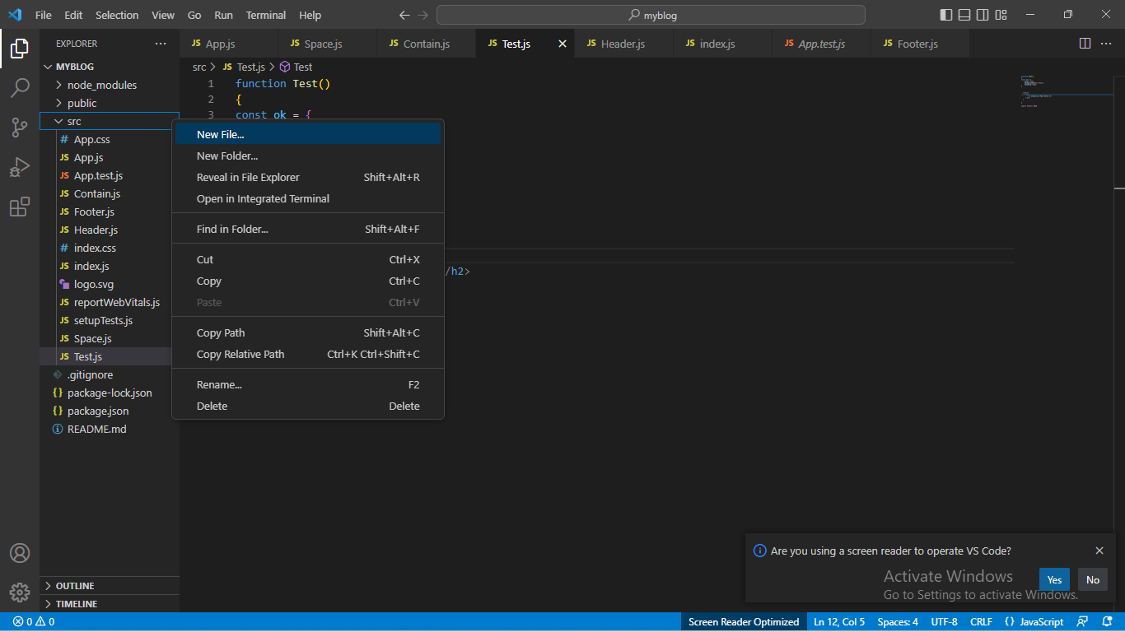
Give the file name with extension .js like Abc.js , Xyz.js etc.
Filename first letter always in capital latter like Abc.js, User.js.
Two types of Component
1 Functional Component (Mostley Use)
function filename()
{
return(
<div> Hello World </div>
)
}
export default filename
2 Class Component
import React ,{component} from ‘.react’
export default class filename extends Component
{
render()
{
Return(
<h2> Hello world </h2>
)

}
}

Now go to App.js and import these component
Import filename from ‘./filename’
And write <filename/> tag inside return ().

2 . Use of Style CSS
function Test()
{
const ok = {
color:"red",
backgroundColor:"black",
fontSize:"30px"
}

return(
<div>
<h2 style={ok}>Test here</h2>
</div>
)

}

export default Test

3.How to install bootstrap in React.js?

Step 1 ) Run this command : npm install bootstrap
Bootstrap installed with Latest version.

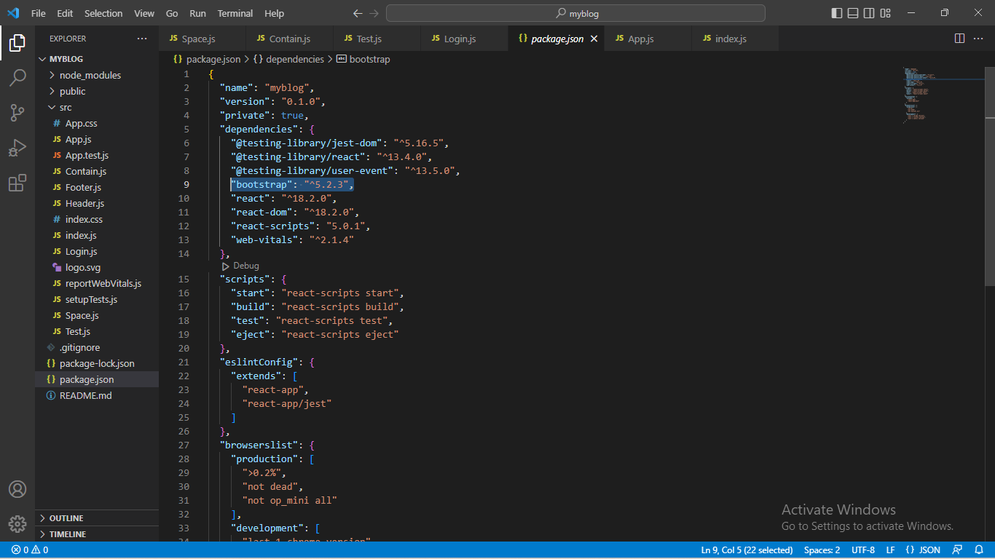

Step : 2)

As of now bootstrap is successfully installed in React app but to use it we must import it inside React file. I am importing Bootstrap minified CSS file and Bootstrap JavaScript minified bundle file inside index.js .

import 'bootstrap/dist/css/bootstrap.min.css';
import 'bootstrap/dist/js/bootstrap.bundle.min';

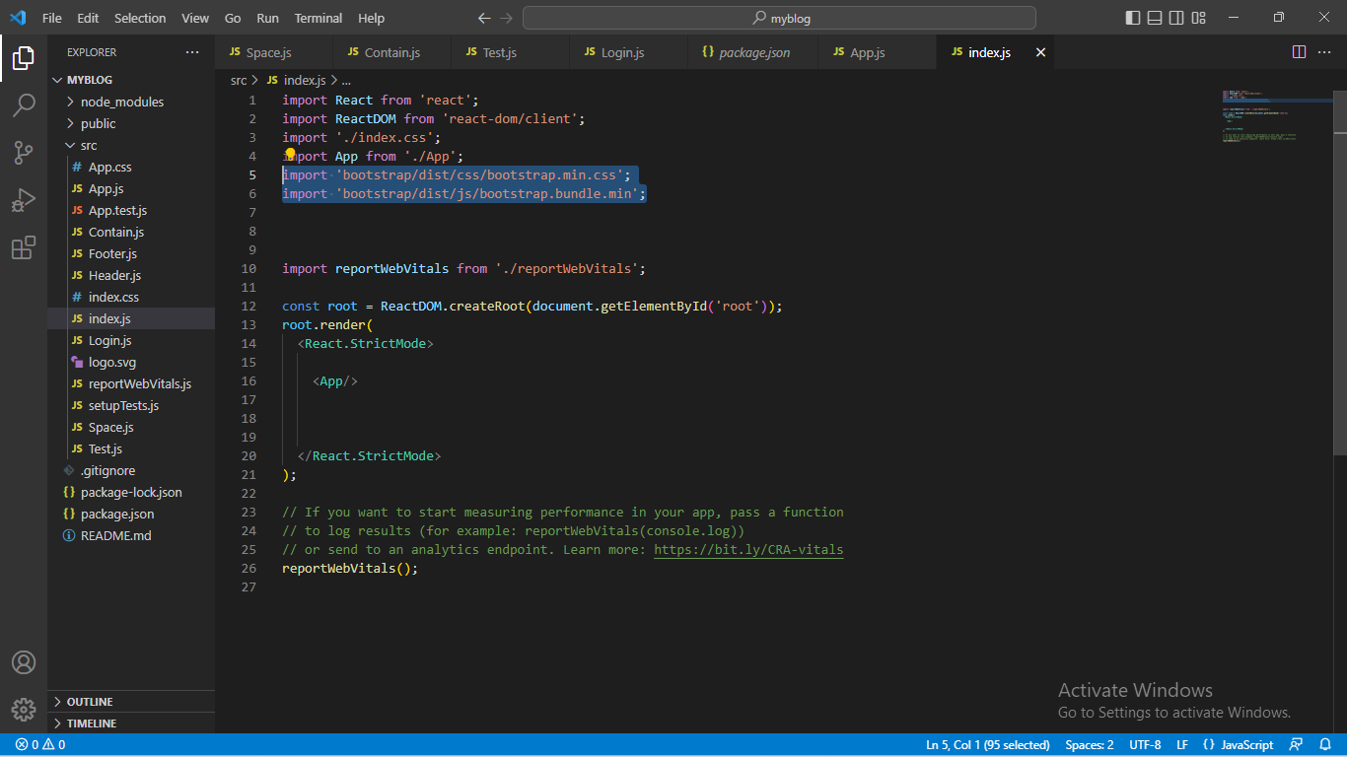

Step : 3)
We are all set to use built-in Bootstrap classes but to use Bootstrap’s JavaScript components in our react app we have to install popper.js and jQuery. In case they are not installed already. To install both jQuery and popper.js write the following line in terminal and hit enter.

4.Work With States

In Class Component
import React,{Component, Setstates} from "react";

export default class UseStates extends Component{
constructor(){
super();
this.state={
Fname : "Akash",
Lname : "Choudhary"
}
}
setRec()
{
alert(this.state.Fname);
this.setState({Fname:"Deepak"})

}
render(){

return(

<div>
<h4>{this.state.Fname} {this.state.Lname}</h4>
<button onClick={()=>this.setRec()}>Click</button>
</div>

)

}
}

Output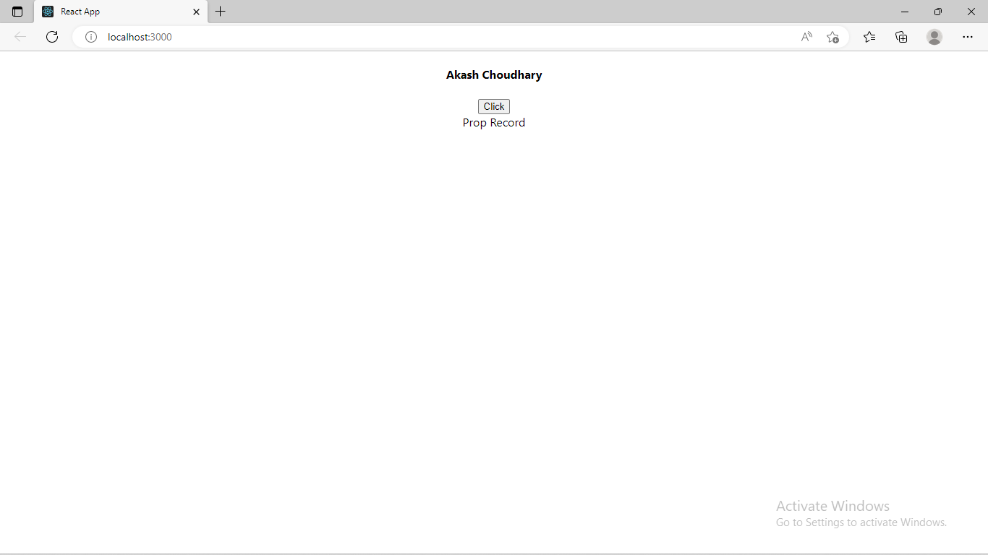

After Click on Click Button
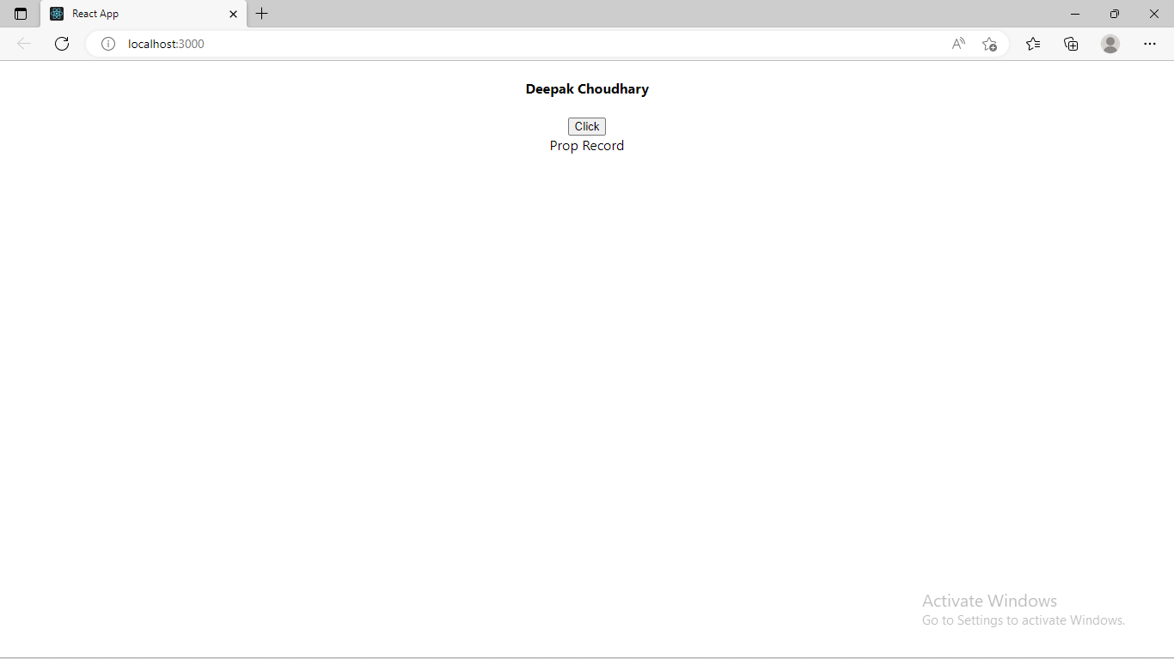

States is used to contain data or information about the component. A component's state can change over time; whenever it changes, the component re-renders.

In Function Component it was not possible to use state in functional components because the setState() method was only supported in the class components. But with React hooks, now it is possible to use state in functional components.

5. Work With Props
It use to Pass data from parent component to child component.
- Props stands for properties.
- Props are arguments passed into React components.
- Props are passed to components via HTML attributes.
- React Props are like function arguments in JavaScript and attributes in HTML.
- To send props into a component, use the same syntax as HTML attributes.
For Use of Props it is need to be installed with using of the command
Cmd : npm install prop-types
Now import props in app.js
import PropTypes from 'prop-types'

In Class Component
Create component Useprop.js and add its tag in App.js
import React, { Component } from "react";

export default class Useprop extends Component{

constructor(){
super();

}

render(){

return(
<div>
{this.props.text}

</div>

)
}
}

Props is used to send record (Data) from one component to another component.
App.js
import logo from './logo.svg';
import './App.css';
import UseStates from './UseStates';
import Useprop from './Useprop';

function App() {
return (
<div className="App">
<UseStates></UseStates>

<Useprop text="Prop Record"></Useprop>
</div>
);
}

export default App;

NOTE : SHIFT+ALT+F (Press these key and code is automaticly adjust)

If you want to use shortcut to import files , need to be add extension Es7 show below screenshot. Click it and install.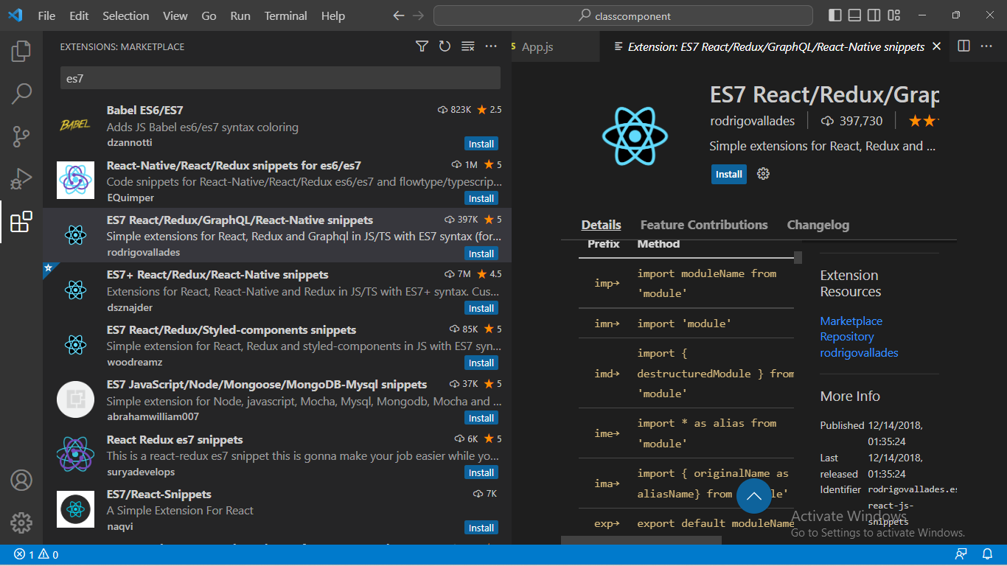
Now type impt, impr etc and Press Enter , you can see more shortcut and use it.

6. How to work with query string

- Send parameter with query string

<a href={`/?id=${userObj.id}`}>

<img src={userObj.image} width="200px" height="200px" title="click" alt="logo"/>
</a>

Add href with <a href={`page_name/?parameter=${id}`} content
</a>

- Get Parameter from another page with query string

import { useLocation,Link } from "react-router-dom";

const queryParams = new URLSearchParams(window.location.search);

const id = queryParams.get('parameter');

console.log(id);

- Add this parameter with URL
const fetchData = (id) => {
debugger;
return fetch("https://fakestoreapi.com/products/"+id)
.then((response) => response.json())
.then((data) => setUser(data));

}

useEffect(() => {
fetchData(id);
},[])

7. Create Navbar With Using of Route

Step 1: Install React Router

If you haven't install React Router in your React project then Install React Router
- npm install react-router-dom

Step 2: Create the Basic Structure
- App Component: Set up the main application component with routing.
- MenuBar Component: Create a navigation menu.
- Pages: Create simple components for each page you want to navigate to.

Create Menubar.js file
import React from 'react';
import { Link } from 'react-router-dom';

const MenuBar = () => {
return (
<nav>
<ul>
<li>
<Link to="/">Home</Link>
</li>
<li>
<Link to="/about">About</Link>
</li>
<li>
<Link to="/contact">Contact</Link>
</li>
</ul>
</nav>
);
};

export default MenuBar;

Pages
Create Home.js file
import React from 'react';

const Home = () => {
return <h2>Home Page</h2>;
};

export default Home;

Create About.js file
import React from 'react';

const About = () => {
return <h2>About Page</h2>;
};

export default About;

Create Contact.js file
import React from 'react';

const Contact = () => {
return <h2>Contact Page</h2>;
};

export default Contact;

Create Styles.css file (Optional)
nav {
background-color: #333;
padding: 1rem;
}

nav ul {
list-style-type: none;
display: flex;
}

nav ul li {
margin-right: 20px;
}

nav ul li a {
color: white;
text-decoration: none;
}

nav ul li a:hover {
text-decoration: underline;
}

Import this file in App.js
import React from 'react';
import { BrowserRouter as Router, Route, Routes } from 'react-router-dom';
import MenuBar from './MenuBar';
import Home from './Home';
import About from './About';
import Contact from './Contact';
import './Styles.css';

const App = () => {
return (
<Router>
<div>
<MenuBar />
<Routes>
<Route path="/" element={<Home />} />
<Route path="/about" element={<About />} />
<Route path="/contact" element={<Contact />} />
</Routes>
</div>
</Router>

);
};

export default App;

